Annual CIPAC/FAO/WHO Report Form
on the Quality Control of Pesticides

Country/Name and Address of the Institution (contact person):
Panamá, Ministerio de Desarrollo Agropecuario, National Direction of Plant Protection,
Laboratory of Quality Control of Pesticides Formulation
Contact person: Brenda Checa Orrego; email: bcheca@mida.gob.pa

1 - Essential Information

Reporting period/year: | Number of samples analyzed (1) | Number of non-compliance (2) | Uses (3)  (optional)
2013 | 171 | 3 | Agricultural use: X
2013 | 171 | 3 | Public Health use:
2013 | 171 | 3 | Home and Garden use:
2013 | 171 | 3 | Other uses (please specify):
(1) Any sample, including those of active inspection and registration control samples.
171 samples

(2) Non-compliance with FAO/WHO or national pesticide specifications.
3 samples

The reason of non-compliance:
3 non-compliance:

- 2 samples no compliance of content of active ingredient (1 high and one low)
- 1 sample no compliance of emulsion characteristics and reemulsification properties

(3) If possible, please indicate the use/destination of the pesticide analyzed if the pesticide has various uses, it should be included only in one category and should be explained under item 2 (comments).
-Agricultural use

2 - Any comments and/or background information

171 samples for 52 active ingredients were analyzed in National Monitoring Program for Quality Control of Plant Protection Products in 2012.

The samples analyzed according to class en 2012 were 51 herbicides, 83 insecticides, 37 fungicides. 1,8 % of the samples analyzed no compliance, corresponding to 3 insecticides.

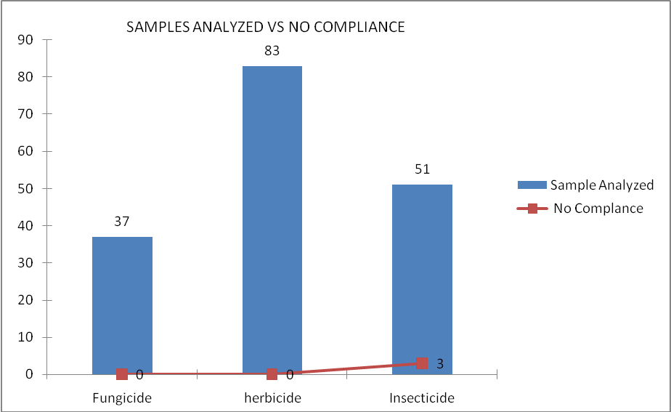

The majority of group analyzed were: organophosphate, pyrethroid, glycine derivate and phenoxycarboxilic acid.

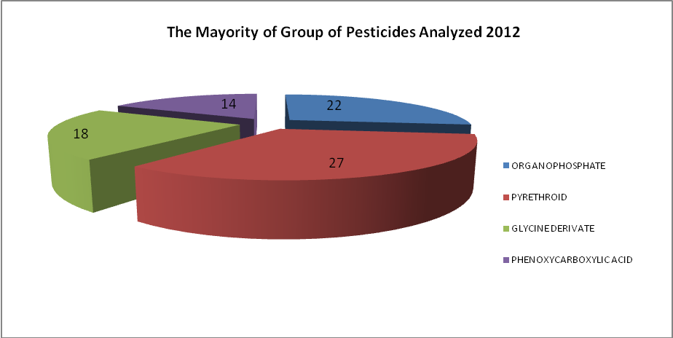

3. CIPAC Activities

- ETU CIPAC Collaborative Study (Cerexagri B.V.).

